SAUMYA MARY SUNNY

PERSONAL DETAILS: |  |  | 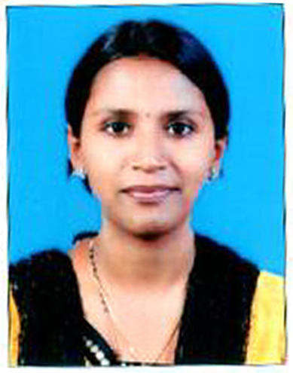
Post Applied For | : | NURSE
Total Experience | : | 11Years
Gender | : | Female
Date of Birth | : | 17-10-1985.
Marital Status | : | Married
Nationality | : | Indian
Present Address | : | A block 506, yashraj avenue, bikrai nagar fursungi pune 4123088.MAHARASTRA
Permanent Address | : | SUNNY PETER SHIAKH BUILDING  VIJAY NAGAR, HINDALGA, BELGAUM.  PIN CODE NO.: 591108. KARNATAKA, INDIA.
Contact Telephone Number | : | +91 9765608486
Email id: | : | saumyamoses7@gmail.com
Indian Residential Status |  | Citizenship
Passport No. |  | K9775046
Issue Date: |  | 1ST February 2013
Expire Date: |  | 31st January 2023.
Issue Place: |  | BANGALORE

PROFESSIONAL QUALIFICATION:

Qualification | Institute | Year | Remarks
GENERAL NURSING AND MIDWIFERY | SHAIKH INSTITUTE OF NURSING, afflicted to Karnataka Nursing Council. Recognised by Indian Nursing Council. | 2007 | 74%

ACADEMIC QUALIFICATION:

Qualification | School / College | University | Years | Remarks
S.S.L.C. | St. JOSEPH CONVENT HIGH SCHOOL | KARNATAKA BOARD | 2002 | PASSED
P.U.C. | St. XAVIER PRE UNIVERSITY COLLEGE | KARNATAKA STATE  DEPARTMENT OF PRE-UNIVERSITY EDUCATION | 2004 | PASSED

CURRENT REGISTRATION:

DETAILS OF REGISTRATION IN THE HOME COUNTRY:
NURSING REGISTRATION | REGISTRATION NUMBER
KARNATAKA NURSING COUNCIL | Nurse and Midwife | 04DN16589

EMPLOYMENT AND EXPERIENCE DETAILS:
Name of Institute | Position Held | Duration | Areas worked
BOMABAY HOSPITAL,INDORE | STAFF NURSE | JANUARY 2008 TO FEBURARY 2010 | MEDICAL AND SURGICAL WARD
HOPE RECOVERY CENTRE | STAFF NURSE | JUNE 2010 TO AUGUST 2012 | EMERGENCY CARE AND COUNSELLING
SPANDAN MULTISPECIALITY HOSPITAL | STAFF NURSE | AUGUST 2012 TO JULY 2016 | INTENSIVE CARE UNIT AND GENERAL WARD
COLUMBIA ASIA HOSPITAL PUNE | INCHARGE | FEBURARY 2017 TO MARCH 2018 | NICU , LDR AND OPD
MAHINDRA UNITED WORLD COLLEGE | NURSE | SEPTEMBER 2019 TILL DATE | MEDICAL CENTER

WORK DESCRIPTION :

Clinical Responsibilities in Intensive care Unit:
- Holistic assessment, planning and implementation of care  - Management and Administration of care includes intravenous therapy, fluid management, blood product transfusion, administration of medication.  - Co-ordination with health personnel  - Interpretation of values.  - Maintaining patient hygiene (oral care, bed bath) urethral  Catheterization | - Following standing orders in emergencies  - Collecting samples  - Insertion of Nasogastric tube as well as administration of feeds  - Tracheostomy care and Colostomy care  - Discharge education  - Maintaining records and reports.

LANGUAGES TO BE KNOWN:

ENGLISH, HINDI, MALAYALAM, KANNADA, MARATHI, TAMIL .

DECLARATION:

I hereby declare that the above furnished details given by me are true to the best of my knowledge and belief and can support by relevant certificates and documents.

Date :8/03/2021 | Yours sincerely  (SAUMYA MARY SUNNY)  Signature

